**Kol simcha torah gazette**

**For parshas noach 5784**

Volume 8 Issue 6 (Whole #364) 6 Mar Cheshvon 5784/ October 21, 2023

**Printed L’illuy nishmas Nechama bas R’ Noach, a”h**

For a free subscription, please forward your request to [***keren18@juno.com***](mailto:keren18@juno.com)

***Past emails can be found on the website ShabbosStories.com under Brooklyn Torah Gazette***

**“For These I Cry’**

**By Chaya Sora Jungreis-Gertzulin**

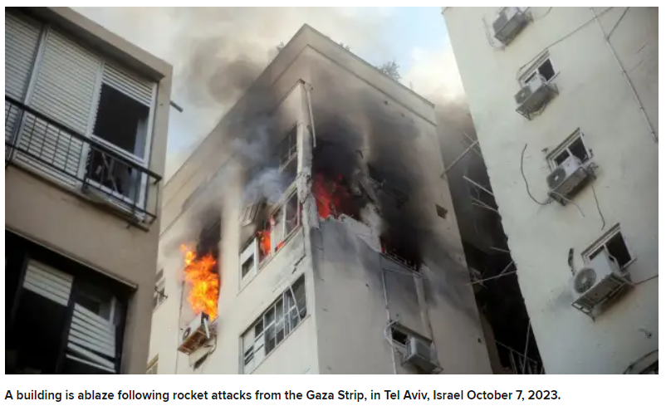

Can it be? It’s happening again… only worse. I remember Yom Kippur, fifty years ago. We were in shul, when we heard the devastating news. War in Eretz Yisroel. A surprise attack on Yom Kippur, holiest of days. All reservists were called up. Chayalei Yisroel, many still in their kittels and tallesim, all with a prayer on their lips. They ran to battle, ready to protect their people, their nation, their land.

That year, our tefillos took on extra meaning as we begged HaShem to protect Am Yisroel, to guard Eretz Yisroel. Who didn’t tremble that day as we recited the passages of Avinu Malkeinu and Shema Koleinu. That Yom Kippur, there was no “break” during the day. We remained in shul with our Tehillim, davening for our people’s safety.

The Yom Kippur War became a distant memory, a thing of the past. A memory our children don’t have, and our grandchildren are so far removed from. We’ve become complacent with our lives, and comfortable with the Eretz Yisroel of today. Yes, we go to mekomos hakedoshim, holy places, and daven for ourselves and our families. At the same time, we hit the malls, we feel safe in  
its luxurious hotels, and enjoy its gourmet restaurants. We walk Israel’s streets  
marveling at all the “progress” that this modern country has made over the past few decades.

**The Worst Offensive Attack in Israel’s History**

This Shemini Atzeres and Simchas Torah we were forced to remember. Once again, a surprise attack on Yom Tov. It is with pain in my heart that I write about an offensive attack, said to be the worst in Israel’s history. An estimated one thousand terrorists infiltrating the country by land, sea and air. They invaded several communities, going from house to house, taking hostages, torturing and even brutally slaughtering innocent men, women and children, all while yelling Allah Akbar.

I can’t get the images out of my mind. Young women pleading for their lives, crying children and infants being tortured, and even the elderly dragged away into captivity. The terrorists were so brazen as to video their heinous acts,  
posting it in real time on social media to show the entire world the full extent of  
their murders and brutality.

The Navi Yirmiyahu says in Megillas Eicha, “Al eileh ani bochiyah, For these I cry.”

How can we not shed a tear?

**Recalling the Words of King David**

Families torn apart. Men, women and children tortured and taken hostage. Young lives of soldiers, border police, and others cut short. For these I cry. As David HaMelech writes “Eileh ezkara v’eshpecha alai nafshi, For these I recall and pour out my soul for what has befallen me.” (Tehillim 42:5).

We owe it to these holy neshamos to shed a tear for them. The kidnapped Israelis were paraded through the streets of Gaza, while being jeered and spat upon by Palestinians. I remember my mother a”h telling me of when the Nazis invaded her home town of Szeged. Jewish residents were forced to march through the streets while their Hungarian neighbors laughed and spat upon them.

Ima would say that she is so afraid that it’s going to happen again. I was young and naïve and thought that the world changed. That somehow “they”  
(whomever “they” would be) would never allow this to happen again. How wrong I was.

I am in disbelief as I learn of pro-Palestinian rallies taking place right here,

in our own New York City, calling them “All Out For Palestine”. And the so-called “enlightened” students of Harvard demonstrating in support of the Palestinians, completely oblivious to the brutality and inhumaneness exhibited by  
these so-called “freedom fighters”.

**A Time to Recite Special Tehillim (Psalms)**

I was with my daughter and son-in-law for Simchas Torah. We davened at the Agudath Israel of Five Towns, led by Rabbi Yitzchok Frankel. Like in so many  
shuls, the rov spoke of the terrible situation unfolding in Eretz Yisroel. He requested that each hakafah be somewhat shortened, and he led the shul in reciting Tehillim.

The rov spoke from the heart, urging that a proper balance be struck between the obligation to rejoice on Simchas Torah with the reality of the tragic events of the day. Yes, we sang and danced with our Torah, while having in mind our brothers and sisters, acheinu kol beis yisroel, in the Holy Land. Rabbi Frankel reminded us thatit was our duty to feel our brothers’ pain.

As Jews, we must be nosei b’ol im chaveiro, to feel another’s pain. Rav Yechezkel Levenstein zt”l the Ponovezher mashgiach said that nosei b’ol means that a person must feel toward another just as if the distresses and pain are exactly his own.

We must do for them. To daven, to give material and financial support. There are amazing volunteers who have already flown to Israel, some to be soldiers, others to offer medical and other assistance to the injured, to the grieving families and to so many who have been traumatized by events of the past  
few days.

**The Last Day and Final Brachos of Moshe**

On Simchas Torah we read the final portion of the Chumash, V’Zos Ha’bracha. The story of Moshe’s last day and his final brachos to his beloved people. We read of HaShem showing Moshe all of Eretz Yisroel  
from atop Har Nevo. “And HaShem showed him the entire land… as far as ‘hayam  
ha’acharon’, the end of the sea (the Mediterranean Sea).”

Rashi (Devarim 34:3) teaches that “hayam”, the sea, can be read and understood as “hayom” ha’acharon, the last “day”. HaShem showed Moshe the full  
history of the Jewish nation that would play out through time, to the end of days, to the time of techiyas ha’meisim.

Moshe gave brachos, not only for his generation, but for all time. Brachos that speak to us today. One of Moshe’s brachos was “Barzel u’nechoshes min’alecha…May your borders be sealed like iron and copper…” (Devarim 33:25). “There is no one like HaShem… He rides across heaven  
to help you.” (Ibid 33:26).

We ask Moshe…. Please, please plead  
before HaShem on our behalf. May your bracha of secure borders be with us. May we have the strength to endure these difficult days.

*Reprinted from the October 11, 2023 email of The Jewish Vues.*

**Rav Avigdor Miller on**

**When Hashem Created the**

**World, What Came First,**

**The Chicken or the Egg?**

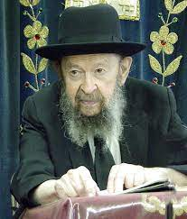

It’s a big problem for the scientists, a problem they can’t answer. What came first? If the egg was first, then there was no mother to hatch it. But if the chicken was first, so how did the chicken come? It’s a problem for them.

And the answer is, both were first. Hashem said, “Let there be chickens sitting on eggs.” When the world was created there were thousands, maybe millions of chickens sitting on eggs at the very beginning of the world. That’s the only way to solve the problem. Otherwise, there are too many contradictions.

When Hashem made the world, He made it ready, functioning. Right at the beginning of briyas haolam, He put metal into the earth; He put iron into the earth. Trees were growing and rivers were flowing and chickens were sitting on eggs. Everything was put there. Just like when Adam HaRishon was created, he didn’t wait for someone to come along and give him a pair of eyes. As soon as he was born, he had a pair of eyes and he could talk and he had a full set of teeth too. Same thing, so as soon as the earth was created, it had everything that it needed.

That’s what the chachomim say (Chullin 60a). All of Creation came into being b’komasan; it means the world came into being as a fully functioning and complete world. And included in that is that there were old chickens and young chickens and chicks and chickens sitting on eggs too – He created,– out of nothing; everything came into being immediately, functioning immediately. And so, the world came into being with chickens sitting on eggs.

*Reprinted from the Parshas Bereishis 5784 email of Toras Avigdor based on Rabbi Avigdor Miller’s Tape #E-171 from his classic Thursday night lectures (December 24, 1998)*

**Thoughts that Count**

**for Our Parsha**

*And take to you of all food that is eaten...and it shall be for food for you, and for them* (Gen. 6:21)

When a righteous person consumes food, the food fulfills its purpose in creation, becomes spiritually elevated, and "justifies" its existence. G-d therefore told Noah, "It shall be food for you, and for them [i.e., spiritual sustenance for the various foods themselves]." *(Tiferet Shlomo)*

*Reprinted from the Parshat Noah 5761/2000 edition of L’Chaim.*

**Comparing the Service of Noah to that of Abraham, Moses and King David**

**From the Teachings of the Lubavitcher Rebbe**

**Rabbi Menachem Mendel Schneerson, Zt”l**



This week we read the second portion of the Torah, Noach (Noah). In describing the virtue of Noah, the Torah states: "Noah was a righteous and wholehearted man in his generations."

Our Sages emphasize that Noah was considered righteous in comparison to his own morally depraved era, but not in comparison with other generations. The Zohar specifies three generations in which, had Noah lived at that time, "he would have been considered as nothing": the generation of Abraham, of Moses, and of David.

Why were these three particular generations chosen for the comparison?

With each of these generations, a new phase began in the world's development. Abraham, the first Jew, initiated the stage in which the Jewish people started to fulfill its Divine mission. Moses brought the Torah to the world, which marked the beginning of the ability to sanctify and refine physical reality. King David initiated the era of sovereignty, the ultimate objective of which is to establish G-d as King over the entire world.

Noah, too, lived in a time of new beginnings: the world as it exists after the Flood. The Midrash tells us that when Noah went out of the ark "he saw a new world," and began to establish the foundations on which to rebuild it. Nonetheless, because Noah's service was on a very low preliminary level, his contribution is considered "as nothing" in comparison to the service of Abraham, Moses and David.

**The Failure of Noah’ Generation**

In truth, Noah's righteousness was mainly in comparison with the wickedness of the generation of the Flood. The people of his time were extremely corrupt in the way they dealt with each other. But righteousness in interpersonal relations is not enough to bring the world to its G-dly perfection. While certainly a prerequisite, it merely allows the world to function the way it should.

For this reason, Noah's service is considered "as nothing" in contrast to that of Abraham, Moses and David. Their service went beyond the social realm; they actually connected the world to G-dliness. Abraham disseminated the belief in One G-d; Moses received the Torah at Mount Sinai; and David built the infrastructure for the Holy Temple in which the Divine Presence would rest.

**A Spiritual Service Only Motivated by Fear**

Another difference: Noah's service was primarily motivated by fear; his warning to the people of his generation was connected to the threat of the imminent Flood. The Midrash even states that "Noah was lacking in faith; had the water not reached his ankles, he would not have entered the ark."

By contrast, the service of Abraham, Moses and David stemmed from a deep and inner recognition of G-d's greatness, which enabled them to set the "ground rules" for the world's perfection - a process that will be completed by Moshiach, speedily in our day.

*Reprinted from the Parshat Noah 5761/2000 edition of L’Chaim. Adapted from Volume 35 of Likutei Sichot.*

***\*\*\*\*\*\*\*\*\*\*\*\*\*\*\*\*\*\*\*\*\*\*\*\*\*\*\*\*\*\*\*\*\*\*\*\*\*\*\*\*\*\*\*\*\*\*\*\*\*\*\*\*\*\*\*\*\*\*\*\*\*\*\*\*\*\****

*Noah went in, and his sons...because of the waters of the Flood* (Gen. 7:7)

As Rashi comments, "Even Noah was of little faith; he believed and did not believe that the Flood would come, and did not enter the ark until the waters forced him." When a person trusts in G-d that something will happen, his faith actually helps it occur that much sooner; in fact, the speed with which it happens is in direct proportion to the magnitude of his faith. Thus, Noah didn't want to believe "too much" in the Flood, for fear that his faith would bring it on sooner rather than later.

*(Oheiv Yisrael)*

*Reprinted from the Parshat Noah 5761/2000 edition of L’Chaim.*

**Rabbi Berel Wein on**

**Parshat Noach 5784**



After the destruction of civilization in the great flood a new generation arose and searched for a way to immortalize itself – so that their existence would withstand any new natural disasters. They gathered in the Tigris-Euphrates valley and there built the great city that would be called Nineveh. And to guarantee that their achievements would be forever remembered, they embarked on building a colossal structure – a great tower pointing towards - and seemingly even touching -  the sky.

It was the first ancestor of our modern-day skyscrapers. This was the great technological leap forward in the discovery of creating bricks as a building material, which enabled such a project to be imagined and executed. The Torah specifically relates to us that the sole purpose of this tower soaring heavenward was “to build for us a name” – a remembrance, an eternal monument to human technology and ability that later generations would gaze upon in awe and admiration.

It was a testament to the human ego and its accompanying hubris. That is perhaps what Midrash is implying when it states that, “…..we will prop up the heavens” with this tower. They were saying that puny man could successfully defy G-d and nature and immortalize itself with its technological wonders and its insatiable ambitions.

Every dictator in history has sought to immortalize his achievements in stone and marble lest his greatness becomes unknown to future generations. Almost all of these memorials have failed to live up to their original purpose. The slaves who built the pyramids of Egypt are more well-known than are their pharoanic masters.

The Parthenon and Coliseum lie in ruins and Nineveh itself has long since disappeared from the map of the world. And the great twin towers of the World Trade Center of New York City are also no longer with us.

The irony of all of this is that none of the great architectural monuments of the ancient, medieval and modern world were felled by nature. There was no need to prop up the heavens in order to save Nineveh from destruction. Nineveh and all of the other great monuments of the ancient world were all destroyed by human beings who were themselves bent upon creating their own eternal monuments to their own achievements.

It is part of the inborn competitive nature of human beings to attempt to destroy the immortality of others as a means of guaranteeing one’s own immortality. Thus, we continue to hound people who are already in the grave, searching for scandal and blame. The Torah itself tells us that the tower at Nineveh was never completed because people did not understand each other’s language – basically, they could no longer cooperate one with the other.

The fractiousness and parochialism of humans towards each other is what truly stands in the way of human immortality. Rabbi Yisrael Lipkin of Salant summed up this lesson in his pithy remark: “Concern for the needs of others in this world is my entry ticket to the World to Come.” Torah values and its observance coupled with good deeds, not physical monuments, are our guarantors in achieving immortality.

*Reprinted from the current website of rabbiwein.com*

**From Brooklyn to Gaza**

**In 48 Hours:**

**Chassidic Reservists Rush to JFK on Shabbat after Receiving the Call to Duty**

**By**[**Mendel Super**](https://www.chabad.org/search/keyword_cdo/kid/22695/jewish/Super-Mendel.htm)

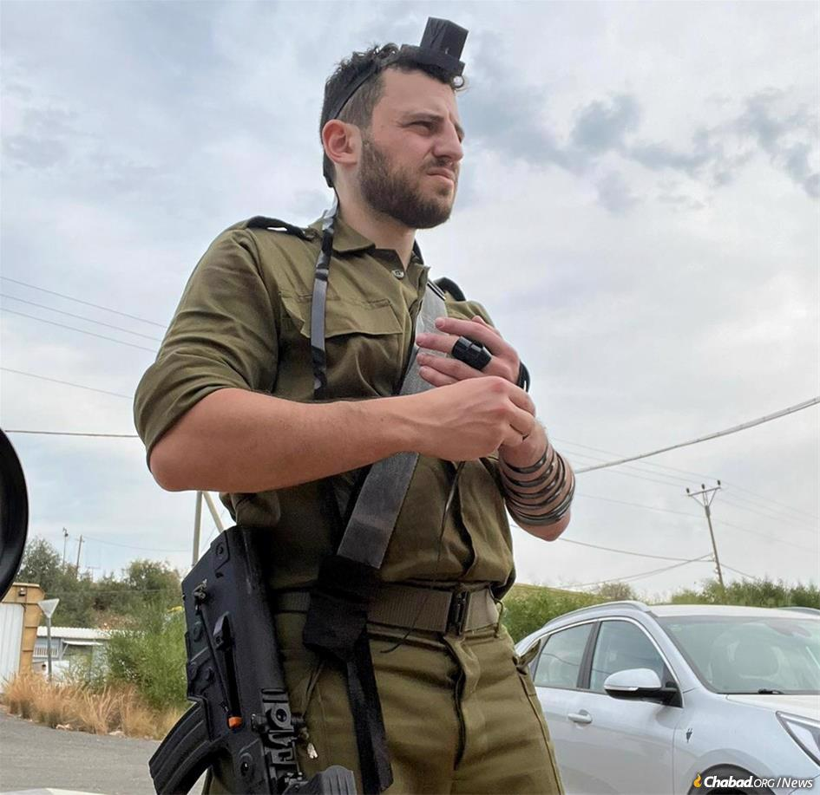

*Chaim Pinson of Miami, a reservist in the Israel Defense Forces, was celebrating Simchat Torah in Brooklyn, N.Y., when called up to serve with his Golani combat unit, rejoining his brothers-in-arms he’d served alongside from 2010 to 2012. Booking the next flight to Israel, he went to his parents’ house to fetch his backpack and some clothing, and to say goodbye.*

Chaim Pinson was celebrating [Shemini Atzeret](https://www.chabad.org/library/article_cdo/aid/4689/jewish/Shemini-Atzeret-Simchat-Torah.htm) in Brooklyn and was ready to retire for the night. It was Friday, and Pinson had spent a joyous evening dancing with the Torah at the central Chabad-Lubavitch synagogue in the Crown Heights neighborhood. Coming from Miami to visit family in New York, where he grew up, the 31-year-old was having a great holiday.

“I was meeting old friends I hadn’t seen in years, catching up on war stories with a friend. I walked home after *hakafot* and went to bed,” he recalls. “In the morning, I was tracked down in my apartment and woken by an old friend who told me what was happening. I was disgusted, horrified and scared. I thought I was dreaming and pinched myself.”

**Saw a Tzav Shmoneh Flashing on His Screen**

Staff Sgt. Pinson, a reservist in the Israel Defense Forces, opened his phone—something he would never otherwise do [on Shabbat](https://www.chabad.org/library/article_cdo/aid/1113745/jewish/Saving-Lives-on-Shabbat.htm)—and saw a *Tzav Shmoneh*, or Order 8, flashing on his screen. He’d been called up to serve with his Golani combat unit, rejoining his brothers-in-arms he’d served alongside from 2010 to 2012. Booking the next flight to Israel, he went to his parents’ house to fetch his backpack and some clothing, and to say goodbye.

Blocks away, Shai Glazer, a resident of Kfar Chabad—the [Chabad](https://www.chabad.org/library/article_cdo/aid/244369/jewish/About-Chabad-Lubavitch.htm) village near Tel Aviv— was also heading to bed, a little after 1 a.m. A member of the Israel Police reserves, he was accustomed to leaving his phone turned on over Shabbat in Israel, and out of habit, did the same while spending the holiday in New York.

Glazer’s phone did not stop buzzing and seeing bits of fractured messages on the home screen, he pieced together that something terrible was underway. In the morning, at prayer services in 770 Eastern Parkway, Chabad’s world headquarters, Glazer heard more rumors. Terrorists had infiltrated Israeli villages and towns. Some of his friends asked the New York City Police Department officers stationed outside the synagogue for more information.

**Asked a Rabbi if He Could Fly Back to Israel on Shabbat**

When the lengthy holiday service concluded at 1:15 p.m., Glazer met two other Israelis outside who appraised him of the situation. “I called Israel immediately; I had an order to report for duty,” he says.

Together with two other friends in the Israeli army reserves, Glazer desperately looked for tickets, but found nothing. A call to Rabbi Shlomi Peles, Chabad’s security and special operations coordinator in Israel, got Glazer the number of a travel agent who would help. That afternoon his phone pinged. The tickets were booked.

Glazer rushed back to 770 to find a rabbi to assure him he was doing the right thing. “If you were in Israel now, would you go? Then you must go from here, too,” the rabbi instructed him.

**Dozens of Reservists Rush to the Airport**

Separately, Glazer, Pinson and dozens of other Chabad reservists took Ubers from Crown Heights and rushed to John F. Kennedy International Airport. “I wore my Shabbat garb, my hat and *kapote* to the airport. It was still a holiday,” Glazer says. At the airport, stunned passengers kept asking him why he was flying on a religious holiday, and Glazer says he saw many other Chabad Chassidim there, too.

“My flight was a mix of civilians and reservists,” Pinson reports. He managed to snag a direct El Al flight at the airport, swiping his credit card for fellow reservists to book flights as well. “It was complete chaos at the El-Al desk.” The reservists encouraged one another during the long flight, and one commando gave Pinson a real morale boost. “He wasn’t afraid of anything. He had a determined and calm demeanor, and helped put me at ease.” Two other Chabad Chassidim were seated near Pinson.

Speaking from an army base in northern Israel, he describes taking a deserted three-hour bus ride from Tel Aviv to join his unit. Walking to the front of the bus, Pinson says he struck up a conversation with the driver: “We spoke about the shock, the barbarity, the brutal nature of our enemies, and we were just shattered and broken. But before I got off, I just said in Hebrew: ‘We are a strong people.’ He smiled. And that gave me all the strength I needed.”

Glazer is stationed with the Jerusalem police, while his two friends who left New York with him are on the southern and northern borders, respectively.

“I have seen a lot of miracles, a lot of horror. There’s no fear here; morale is high, and we are getting so much love from everyone,” he says. “At the same time, we know that we are about to destroy our enemies, and we are ready; there’s no hesitation. I have accepted that I am ready to die, if that is what needs to happen. I left everything behind.”

***To pray for the safety of all residents and soldiers in the Holy Land,***[***Psalms 20, 22, 69 and 150***](https://www.chabad.org/article.asp?AID=809299)***are traditionally said in times of distress.***

***Reprinted from the October 11, 2023 posting on the Chabad.Org website.***

**Israeli Reservist, 95, to IDF: ‘Demolish Hamas’**

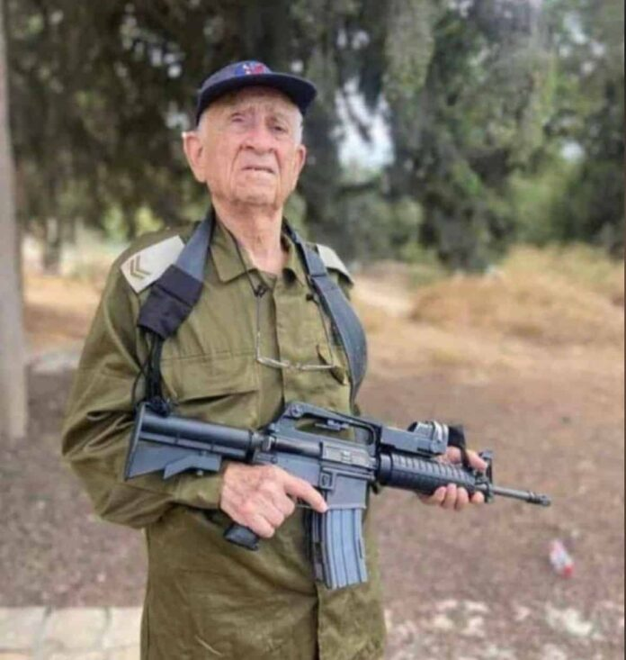

A crowd of young Israeli soldiers stand ready, listening to a 95-year-old, battle-hardened veteran. Ezra Yakhin has witnessed nearly every war the modern state of Israel has faced, and he remembers 1948.

“I told them to go demolish Hamas,” Yakhin, who may be the oldest IDF reservist, told JNS.

Asked how it feels to be the oldest Israel Defense Forces reservist in action, Yakhin told JNS that “it is very important for us to fight for our country. I feel excellent.”

Yakhin won’t be fighting terrorists on the front lines, but his job involves motivating those much younger than he, who will take on Hamas terrorists directly.

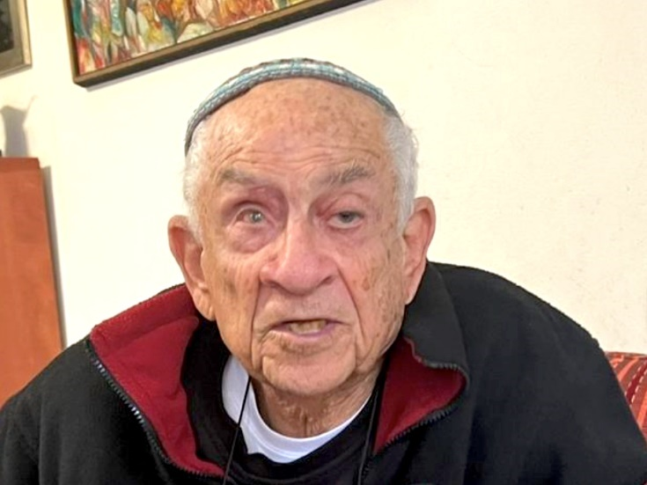

**Ezra Yakhin, 95, who may be the oldest IDF reservist. Photo by Avi Kumar.**

He has seen Israel achieve victory against great odds, as when he joined the Jewish militia Lechi, a thorn in the side of the British police, at age 16. “Nobody thought a small nation like us with less than half a million people could challenge an empire that spanned the entire globe,” he said.

It proved invaluable to the underground movement that Yakhin had a job at the post office and he knew some Arabic. (His parents were from Syria and Egypt.) He found his way to Lehi, in search of whatever group “would be best at kicking the British out,” he said.

“It was very wrong that they were oppressing us in our own homeland, not allowing Jewish refugees to enter and arresting us while the Arabs prepared for war,” he added.

A brother of his was also in Lehi, and Yakhin only learned another brother of theirs was in Irgun when Lehi and Irgun had a joint operation. He had a few major scares, as when he was hit in the thigh by shrapnel on a mission in Jerusalem on Ben-Yehuda Street. During another operation, in the Old City of Jerusalem, he sustained a head injury, which blinded him in one eye.

“We struck such fear in the hearts of the British. They weren’t safe from us, and we made them pay for their actions no matter what it was,” he said.

Asked about Hamas today, Yakhin told JNS that the terrorist group must be put out of business permanently.

“Can the wolves have peace with the sheep?” he asked. “They do not care about the land. This is all driven by their hate for Jews.” *JNS*

*Reprimted from, the October 13, 2023 website of the Matzav.com website.*